Wellbeing Wednesday’s fortnightly newsletter for staff and parents.
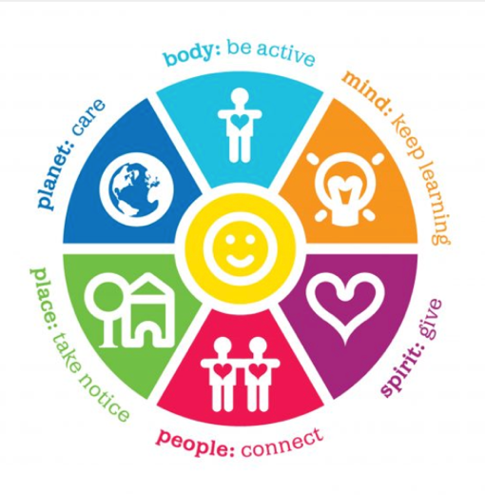
The wheel of wellbeing

Body: Be Active: do what you can, enjoy what you do, have, move your mood. Exercise, do something active that you enjoy, eat well, stay hydrated, sleep well, rest.
Mind: Keep Learning: embrace new experiences, see opportunities, surprise yourself. Make sure you try something new, learn a new skill or hobby and make sure you have fun!
Spirit: Give: your time, your words, your presence. Make sure you give time to others -100%, raise money for charity, help people.
People: Connect: talk &listen, be there, feel connected. Make sure you talk to, listen & spend time with people you love and who make you feel loved, listen to music, spend time with pets or in the garden
Place: Take Notice: Remember the simple things that give you joy. Notice and give time to those little things that give you pleasure, connect with nature, practise mindfulness, cook, read, sing, draw, laugh
Planet: Care: enjoy the planet, be curious, the natural world is a very big one. Spending time outside helps to make us feel better and can act as a mental reset when we need a break. Being aware of nature whilst we’re outside is even better for us.

Using the wheel of wellbeing, the fortnightly newsletters will incorporate spokes from the above the wheel.

Newsletters to include ideas such as:
- Manage your time | - Just breathe
- It’s good to talk | - Food and your mood
- Creating healthy work life boundaries | - Happy hormones
- Read between the lines | - Video call overload
- Recharge your battery | - Remember to ask

