Swan Wynd
Staindrop
Darlington
County Durham
DL2 3NL
Tel: 01833 660334
e.mail: staindropce@durhamlearning.net
www.staindrop-pri.durham.sch.uk

Head Teacher: Mr S Whelerton
Acting Deputy Head: Mrs C Harland
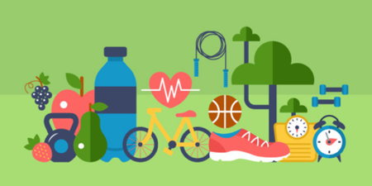
Well-being Wednesdays
Happy Hormones
Hormones are chemical messengers, that travel in your bloodstream to help regulate processes in your body. They are involved in many functions not least of all breathing!
The human body secretes roughly 50 hormones. If your body produces too little or too much of a hormone it can make you very ill and set you up for a number of serious health problems. Within the 50 hormones that you have, there are 4 ‘happy hormones’ that can positively affect your mood. The early darker nights and dark mornings are creeping back in which can also affect our moods.

These 4 ‘happy hormones’ are:
- Dopamine - ‘The reward chemical,’ results in feelings of well-being, it is a lead driver of the brain’s reward system, it spikes when we experience something pleasurable whether it be food, shopping, playing sports etc.
- Oxytocin – ‘The love hormone’, best known for its role in bonding and attachment, it spikes with any sort of intimate touch i.e., holding hands, cuddling, kissing
- Serotonin – ‘The feel-good hormone’ plays a key role in keeping anxiety and depression at bay. Exercise, being outdoors and sleep helps boost your serotonin levels.
- Endorphin –‘The pain killer’ most commonly linked with exercise. Endorphins are associated with ‘runner’s high’ the best way to increase endorphins is exercise. They are powerful hormones as they act as natural pain killers, minimizing discomfort and maximizing pleasure. This is why athletes can push past pain during a tough race or big game.
So, to boost all 4 ‘happy hormones’ you can add these simple activities into your day:-
- Take time for self-care after all you are worth it – massage, listening to music, taking a nap, meditating, spending time outdoors, watching TV- especially a comedy!
- Celebrate little wins – even if it’s as simple as finishing your cuppa whilst its hot.
- Give a compliment -everyone is a. winner
- Exercise – don’t see it as a chore, doing it actually makes you happy
- Vitamin D -most important vitamin -the sunshine vitamin
- Laugh -you are never fully dressed without a smile!
If you still feel down, talk to a healthcare professional, it could be that there might be some nutrient deficiency, getting the right treatment is key.
Take care, Mrs B

